University of Miami
Coral Gables

Tree Care Plan
11/26/2021 |  | Campus in a Tropical Garden
 |  | The University of Miami Coral Gables campus has a unique landscape character with elements designed specifically for its climate and natural setting. It conveys a positive and unified sense of place, coherency, and consistency. Its thoughtful landscape planning has become renowned worldwide as a “campus-in-a-tropical garden”.
INTRODUCTION

The campus enjoys a number of important vegetated areas which include Lake Osceola, The Gifford Arboretum, the Ibis Natural Trail, the Palmetum, the Florida Keys Arboretum and the Butterfly Garden. Our goal is to preserve and enhance the following important features:

- Lake Osceola, the central and distinctive body of water which should be surrounded with tropical vegetation. Natural edges should be preserved, and Native landscaping surrounding it should be promoted.
- The Palmetum: Established in cooperation with Fairchild Tropical Garden and the Montgomery Botanical Center, the University’s palmetum includes nearly 800 palms and cycads that are native to South Florida or represent distinct, rare, or endangered species from 38 nations.

- The Florida Keys Arboretum: This arboretum highlights trees and shrubs native to the Florida Keys as well as some species characteristic of pineland regions. Some of this collection may be relocated in accordance with our housing project in 2020.

- The Butterfly Gardens: Located along the Ibis Walking Trail behind Eaton Residential College and next to the Gifford Arboretum, the Butterfly Gardens are living laboratories. They are home to some 23 different varieties of plants and attracts butterflies such as the monarch, sulfur, and brush foot, as well as the zebra longwing, Florida’s state butterfly.

- The Gifford Arboretum is part of the College of Arts and Science and it is managed by its Director with advice from an Arboretum Committee which includes faculty, students, administrators, and community members. The Arboretum contains a diverse collection of over 650 trees and shrubs representing over 500 species from every continent except Antarctica. The collection is maintained for purposes of education and research, as well as to inspire interest in tropical plants and a better understanding of their importance.

- The Sustainability Garden at the Arboretum is host to various edible trees, shrubs, and herbs. The Garden is used by a wide range of faculty members from the College of Arts and Science who chose to teach part of their class there and use it as an academic and research tool.

University of Miami Coral Gables

Campus in a Tropical Garden
Standard 2
1- PURPOSE
The goal of the University of Miami Tree Care Plan is to establish and highlight good and sustainable landscaping practices on our Coral Gables campus.
The general purpose of the plan is to describe the standards of beauty, sustainability and environmental stewardship applied on our campus landscape.
Specific objectives of this plan are:
- Develop environmentally friendly landscape designs to conserve energy and water, reduce the urban heat island effect on campus, and promote improvements in air quality.
- Use of Native plants or low-maintenance plant species
- Administer environmentally sound arborist practices to enhance and maintain the campus landscape.
- Increase species diversity and tree canopy.
- Protect existing campus canopy during construction and renovation projects.

2 - RESPONSIBILITY
UM Facilities Management Department will manage the Coral Gables Campus Tree Care Plan in partnership with the Campus Tree Advisory Committee members.

Standard 1
3 - CAMPUS TREE ADVISORY COMMITTEE

The committee is comprised of students, faculty, staff, and community partners. The committee meets twice a year to review progress on yearly objectives. The committee responsibilities include: providing suggestions for improvements of the campus landscape and the Tree Care Plan; organizing an annual Arbor Day celebration and service learning projects; increasing tree value awareness throughout the university community, and activities that supports its Tree Campus USA certification each year. New members are nominated and approved by the standing committee members each year. Here is the list of our 2019 committee members:

Name | Status | Title | Email
Teddy Lhoutellier | Staff | Sustainability Manager | teddyl@miami.edu
Son Vo | Staff | Sr, Manager for Contract Admin, Contract Administration | s.vo@miami.edu
Fernando Remedios | Staff | ABM Grounds-Landscaping Manager | fernando.remedios@abm.com
Nathaniel Cockshutt | Faculty | ISF Certified Arborist – Fairchild Tropical Botanic Garden | trees4soul@gmail.com
Dr. Terri Hood | Faculty | Professor & Assist. Dir. of Undergrad Program, Center for Ecosystem Science and Policy, Leonard and Jayne Abess | thood@rsmas.miami.edu
Dr Mauro Galetti | Faculty | Director of the Gifford Arboretum,  and Biology professor | mgaletti@miami.edu
Alicia M. Corral | Staff | Campus Planner  Real Estate & Facilities | acorral@miami.edu
Dr. Kathleen Sealey | Faculty | Professor of Biology | ksealey@miami.edu
Jayram, Diya K | Student | Ecosystem Science and Policy | dkj63@miami.edu
Stephen D. Pearson | Staff | Treemendous Miami President | sdpearson@bio.miami.edu
Helene H. Valentine | Staff / Community | Director, Research Support- UM Miller School of Medicine / South Miami Landscape Committee board member | Hvalentine2@med.miami.edu
Aida Curtis | Community | CURTIS + ROGERS DESIGN STUDIO Landscape Architecture- Planning- ISA Certified Arborist®, | aida@curtisrogers.com
Prof. Tim Norris | Faculty | Librarian Assoc. Professor, Richter Library | tnorris@miami.edu

4 - TREE CARE POLICIES

All trees, shrubs, and turf areas are maintained according to landscape management best practices. Those practices include proper and sustainable fertilization, irrigation, and pest management on campus grounds. These guidelines allow us to guarantee the esthetics as well as the health of our landscape while reducing our environmental impact on local ecosystems.

Plant Selection
As stipulated in the South Florida Water Management District's Xeriscape Plant Guide II and the Miami-Dade County Landscape Ordinance, chapter 18 A, our choice of plant species is guided by the Florida Friendly Landscaping (FFL) principles. Native and Low maintenance, drought tolerant species are always preferred. Our irrigation systems also follow FFL’s recommendations, conserving water and promoting soil integrity everywhere possible.
The “Right tree in the Right place” concept is applied in our guidelines to avoid any damage to existing and future infrastructure.
All plant material are required to be Florida No. 1 or better as specified within "Florida Grades and Standards for Nursery Plants" from the State of Florida Department of Agriculture and Consumer Services. (See Annex III)

“The Right Tree in the Right Place”
This concept shall be applied for all trees planted in order to avoid damages such as clogged sewers, cracked sidewalks and power service interruptions. It shall also address specific conditions such as drainage, soil quality, and site orientation.

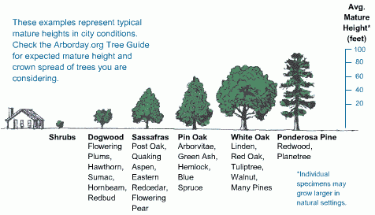
http://www.arborday.org/trees/righttreeandplace/size.cfm

Tree Species Inventory and Selection
- Tree selection shall strive for use of Florida native or "Florida-Friendly" species as much as possible. The Florida-Friendly plant database can be found at http://www.floridayards.org
- The University shall not use category I exotic species, and shall avoid or use judiciously, category II exotic species, as listed within the Florida Exotic Pest Plant Council's Invasive Plant Species List (Annex II).
- Tree selection shall address the following factors: Species diversity, Maintenance cost, urban environment tolerance, Wind tolerance, and Invasive replacement
See our Tree Species Inventory in Annex I for a complete list of species on campus.

Tree Planting
Here are the general requirements for Tree planting in UM landscaping Design standards based on the Miami Dade County Landscape Design Manual (See illustration and Annex III):
- Groundcovers or low growing shrubs shall be used wherever possible to reduce landscape maintenance. Examples include sloped areas, replacement of turf grass in inaccessible or highly shaded areas, erosion prone areas, and areas where mulch washes away or is otherwise difficult to maintain, such as parking lot islands.
- A minimum tree planting area or island shall be ten (10) feet wide by ten (10) feet long.
- Trees shall be located a minimum of ten (10) feet from any underground utility to remain and a minimum of fifteen (15) feet from any overhead utility to remain unless it can be demonstrated that the mature size of the tree will not interfere with the utility.
- Landscape overhanging walkways and plazas to be clear overhead = (10) feet min.
- Trees with circling or girdling roots will not be permitted.
- Install planting soil and amendments as outlined in Division 32 91 00 of UM Building Standards.
- Planting shall be performed by a licensed contractor to the expected standards of care of landscape contractor professionals within the state of Florida.
- Trees and palms shall be planted such that two (2) inches of the root ball is above finished grade.
- Design professional shall be responsible for providing staking and bracing details specific to tree and palm sizes and types for review and approval prior to installation.
- Braces for palms shall be made of sound, new pressure preservative-treated softwood, free of knots, holes, cross grain, and other defects, 2 by 4 inches or 4 by 4 inches, and sized appropriately for the size of the palm.
- Tree staking systems shall use a polypropylene material in green, Arbor Tie by Deep Root, or other approved equal protective material where in contact with branches.

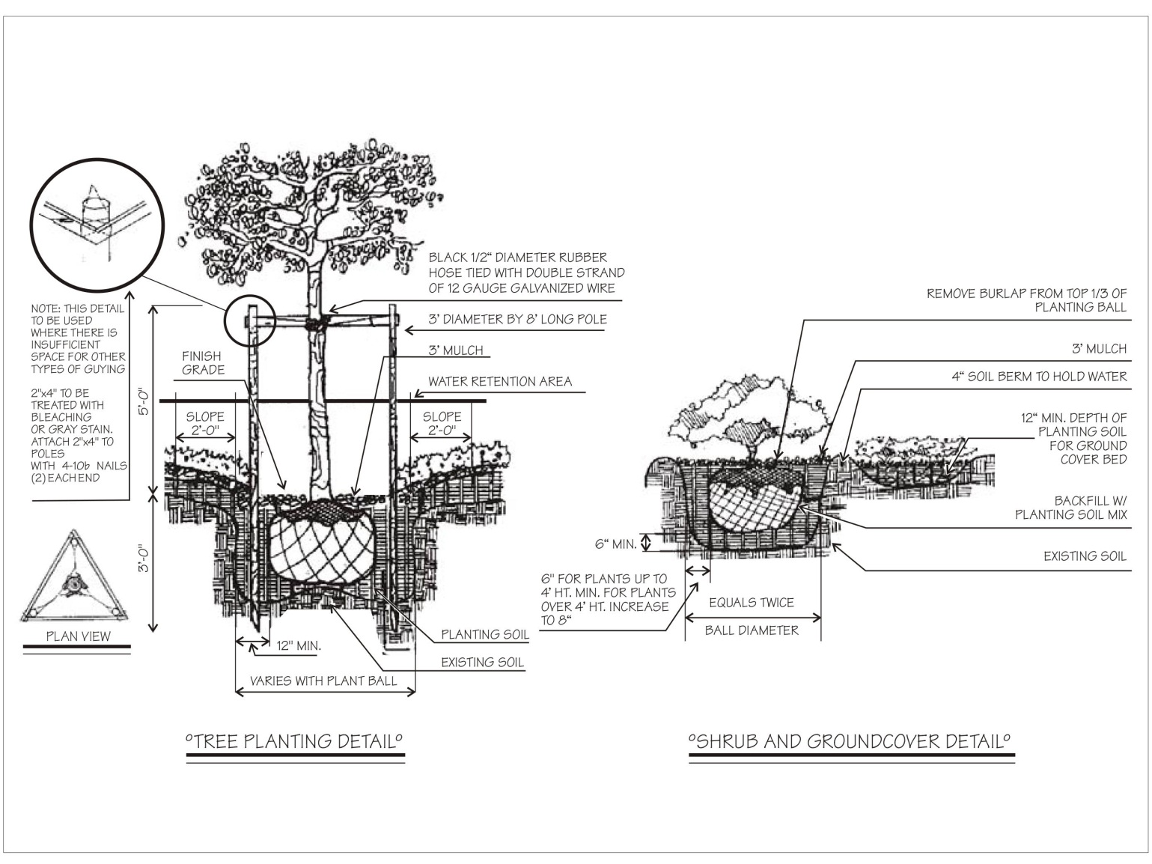

https://www.miamidade.gov/zoning/code-landscape.asp - p67

Irrigation and Watering
Proper Irrigation shall be provided for all proposed landscape, unless otherwise directed by UM Project Manager according to plant requirements, recent rainfall, temperature extremes and soil moisture.

- Water use for irrigation must comply with the Miami-Dade County and SFWMD regulatory requirements as well as with the University's water use agreement with the SFWMD.
- All efforts should be made to connect irrigation to existing well water sources on the University campus.
- Potable water may only be used for irrigation with prior authorization by the UMBS Committee.
- Reclaimed or reuse water shall be utilized as much as possible for irrigation. If used, follow requirements of Florida Statutes Chapter 62- 610, "Reuse of Reclaimed Water and Land Application"
- Drip irrigation shall be utilized as much as possible.
- The irrigation system shall be regulated by a rain-gauge or a moisture sensor.
- Irrigation to provide 100% "head-to-head" coverage.
- Rain Bird brand components or equal shall be specified for all irrigation systems unless otherwise authorized by the University.
- Trees and plants shall be watered in accordance with specifications as provided on the irrigation plan l-5. (See Annex III)

Mulching
Plants shall be mulched on a yearly basis or as needed to maintain healthy growth and reduce weed growth. The maintenance plan follows the best practices stipulated in the Miami Dade Landscape Design Manual
- Mulch shall be organic wood mulch, free from deleterious materials and suitable as a top dressing for planting bed areas.
- Wood mulch shall be used for planting bed areas, as opposed to gravel or other inorganic mulches, as wood mulch inhibits weed germination and growth, holds in soil moisture, moderates soil temperature fluctuations (reducing plant stress), improves the soil fertility through the decomposition of organic material, and decomposes at a moderate rate (reducing maintenance).
- Mulch shall be installed at a depth of 2"-4" and shall be pulled back a minimum of 3 inches from the trunk of the tree or shrub so that the trunk and root flare are exposed.
- Mulch shall be Florimulch by Forestry Resources, Inc. or approved equal Grade A Melaleuca mulch that is clean, bright, and free of weeds, moss, sticks, and other debris.
- Cypress and red color mulch will not be accepted. (See Annex III)

Pruning
The correct pruning of shade trees is critical both for safety as well as for aesthetic reasons. The following criteria are adopted from the ANSI A-300 and are recommended as specifications to be included in landscape plans.
Class 1 - Fine pruning shall consist of the removal of dead, dying, diseased, decaying, interfering, obstructing, and weak branches, as well as selective thinning to lessen wind resistance. The removal of such described branches is to include those on the main trunks, as well as those inside the leaf area. An occasional undesirable branch up to one- half inch in diameter, as described above, may retain within the main leaf area to its full length when it is not practical to remove it. (Diagrams A and B)
Class 2 - Standard pruning shall consist of the removal of dead, dying, diseased, decaying, interfering, obstructing, and weak branches, as well as selective thinning to lessen wind resistance. The removal of such described branches is to include those on the main trunks, as well as those inside the leaf area. An occasional undesirable branch up to one inch in diameter may remain within the main leaf area where it is not practical to remove it.
Class 3 - Hazard pruning is recommended where safety considerations are paramount.
Class 4 - Crown reduction pruning shall consist of the reduction of tops, sides or individual limbs. It involves the removal of a parent limb or dominant leader at the point of attachment of a lateral branch.

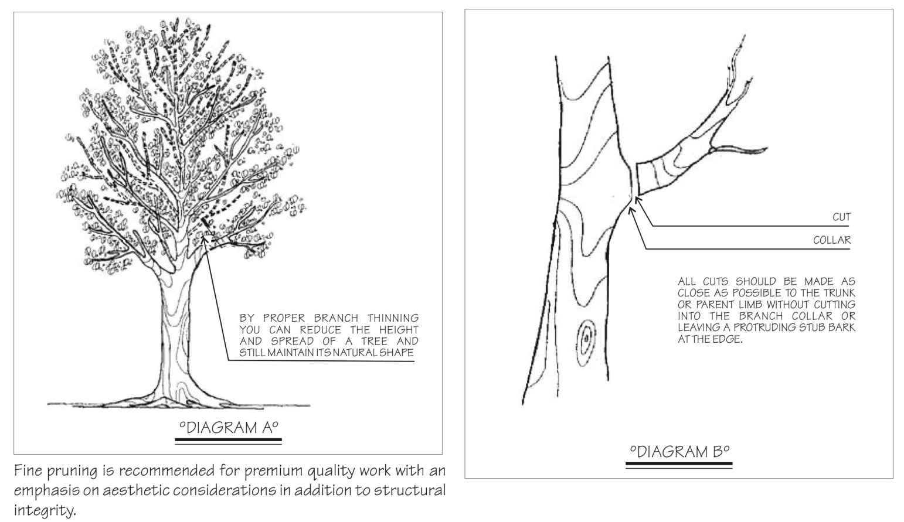
https://www.miamidade.gov/zoning/code-landscape.asp- p92

5 - PROTECTION GUIDELINES DURING CONSTRUCTION PHASES

Tree Protection: All existing trees and specimen plants to remain shall be protected during construction activities.

- Tree barricades shall be used to protect specimen plants and trees to remain larger than four (4) inches in diameter.
- Barricades shall be four feet high, minimum, and constructed of 2" x 4" rails with 4" x 4" posts, minimum.
Barricades shall enclose the specimen plants, trees, or collective tree group's drip line or a fifteen (15) foot by fifteen (15) foot area, whichever is less. No stockpiling of debris, trash, or materials shall be permitted within the barrier area.
- No parking of vehicles or vehicular/equipment traffic shall be permitted within the drip line area or within the tree barricade once erected.
- No landscape planting shall occur prior to a fully functioning irrigation system to support it.
- Each tree proposed for transplanting needs to be inspected by a certified arborist, as certified by the International Society of Arboriculture, for recommendation of the tree's general heath and expected success rate of transplanting. Arborist shall prepare report with recommended preparation and relocation procedures and schedule.
- All transplanting and trimming activities shall be performed by or directly overseen by a certified and licensed arborist.
- A tissue test shall be performed on all trees proposed for relocation.
- A soils test shall be conducted at all proposed relocation points of the site.
- All crown and root pruning shall be conducted as per approved transplanting plan and schedule.
- Transplanting activities other than root and crown trimming will not occur within hurricane season, June 1st through November 30.

6 - GOALS AND TARGETS

The long term goals of the UM Tree Campus USA Plan is as follows:
- Preserve and increase the presence of Native species to promote biodiversity and water conservation.
- Preserve and enhance our tree canopy on the Coral Gables campus, and extend this plan to other UM campuses in the future. The Miller School of Medicine is looking at applying to the Tree Campus Healthcare.
- Use our landscaping design strategy as a way to reduce our carbon footprint, selecting trees that sequester more carbon per square foot and provide shading that will have an impact on the cooling needs of our buildings. This has been the case in all new constructions that are at least LEED Silver. The new Lakeside Village residences reached LEED Gold and included native landscaping as well as Green Roofs (a first for student residences in the region).
- The Frost Institute of Chemistry and Molecular Science will be LEED Gold certified. To reach that certification and stay in accordance with our Tree Care Plan, 44 trees were relocated to create the new bosque area in front of the Merrick Building.
- Allow for storm water retention berms, and bio swales when possible: this was the case in the design of the new Lakeside Village residence that translated in Rain gardens allowing for better management of storm water and water quality. This guideline is part of our water management plan and is intended to also reduce the accumulation of nutrients and pollutants in the runoff to our canals that in turn affect the environmental health of our coastal line.
- Mapping of our Tree inventory, starting with the Arboretum in collaboration with the Geography Dpt and the Computer Science Dpt. A grad student team delivered an app that is being developed semester after semester to track maintenance and serve as pre and post hurricane canopy inventory cloud based map.
- An ongoing research project (ECS 301 on multiple semesters – Dr Terri Hood) involves the study of nutrient cycling in live oak (Quercus virginiana) using stable isotopes. In particular: 1) potential nitrogen sources signals in N isotopes; 2) nitrogen withdrawal from leaves pre-drop; 3) effects of 1 & 2 on use of oak leaves for mulch and compost;
- The Native Habitat Biome located in front of the Arboretum still needs to have all its invasive removed, especially the vines that represent such a threat to our local ecosystems.
- Increase the number of learning service projects at the JC Gifford Arboretum. With the Covid 19 pandemic, 2020 has been a challenging year for engagement to say the least, but we are committed to increase that number in 2021.
- Development of the Sustainable Urban Garden, adjacent to the JC Gifford Arboretum with Dr. Hood and Dr. Weisskoff. Creation of a composting site to help soil amendment in the garden.
- Reach out to the community to bring awareness about the necessity of increasing our canopy, especially in disenfranchised areas of our county: Tree Planting events with TREEmendous and other local organizations.
- Integrate new items in our Tree care plan on a yearly basis: for 2020, welcome our new Gifford Arboretum Director and Professor of Biology, Mauro Galetti. Inauguration in 2020 of the College of Arts and Science new Green House located in front of the Arboretum (PDF).
- Host an annual Arbor Day event on the Coral Gables campus.
- The Medical Campus have planted 2 more butterfly gardens in the past year. A food forest garden was planted in 2021.
- In 2021, Prof Tim Norris on behalf of the University of Miami managed a grant application to the Florida-Urban-and-Community-Forestry-Grants in order to implement an Inventory map and app system for the Coral Gables campus.

7 - TREE DAMAGE AND DISEASE ASSESSMENT

Trees susceptible to serious infectious diseases should not be pruned at the time of year during which the pathogens causing the disease or the insect vectors are most active.

- The presence of any disease condition, fungus fruit bodies, decayed trunk or branches, spilt crotches or branches, cracks or other structural weakness shall be reported in writing to a supervisor and/or the owner, and corrective measures recommended. Native tree species survive better than non-native species.

- The stress to trees as a result of a hurricane damage initiates outbreaks of pests such as bark beetles, ambrosia beetles, sawyers, plant hoppers, and blue stain fungi that preferentially attack stressed damaged trees. These secondary problems have led to the death of trees, including palms, even several years after the storm.
- In addition, after such an event, many trees are damaged internally due to vibration and twisting experienced during the period of high winds. Some of these may die over time. Only 7% of trees studied (Annex III) caused damage to property. Live oak (Quercus virginiana) has exceptional wind resistance here, and in other hurricane prone southern areas. Palms are ranked second in wind resistance. It is important in urban areas for tree plantings to have species, age, and size diversity.
(See annex III)

8 - PROHIBITED PRACTICES

Tree Preservation and Vegetation removal
- Tree removal permits or natural forest community vegetation removal permits are required prior to the removal of trees or any vegetation in a natural forest community pursuant to City Code Chapter 82 and Miami-Dade County, Chapter 18A. ( See Annex IV)

- Desirable landscaping shall be preserved in its natural state to the maximum extent possible. Desirable native plant materials and well adapted exotic plant materials shall be preferred in plant selection.

- Existing trees required by law to be preserved on site and that meet the requirements of Section 18A-6(C), Miami-Dade County Code, may be counted toward fulfilling the minimum tree requirements.
- (See Annex III)

Plant Materials
Plants installed should conform to, or exceed, the minimum standards for Florida Number One as provided in the most current edition of "Grades and Standards for Nursery Plants” prepared by the State of Florida Department of Agriculture and Consumer Services.
Vegetation requirements shall be installed in accordance with all of the following:
- Large shade trees. Large shade trees shall have a mature height of greater than twenty-five (25) feet and an average mature spread of crown of greater than fifteen (15) feet.
- Substitutions. Palms trees or medium shade trees as described in below Section 6(b) (ii) may be substituted at three-to-one (3:1) ratio. A maximum of twenty-five (25%) percent of the total may be palm varieties. (See Annex IV)
- A minimum of thirty (30%) percent of the total trees shall be native species.
- Palm trees and medium shade trees. A minimum of thirty (30%) percent of the total trees shall be native species.
- Shrubs. All shrubs shall be a minimum of eighteen (18) inches in height at planting, with a maximum average spacing of twenty-four (24) inches on center. Shrubs shall be planted and maintained to form a continuous, unbroken, solid, visual screen within a maximum of one (1) year after time of planting. A minimum of thirty (30%) percent of total shrubs shall be native species.

Tree Abuse
All trees shall be trimmed in accordance to Miami-Dade County tree preservation code. Any type of tree abuse, hat racking, topping or heading shall be prohibited except in emergency situations. Contracts with vendors to perform tree services or building construction/maintenance services shall include fines for violating provisions of this plan. Damage to campus trees caused by students, faculty or staff shall be treated as acts of vandalism and punished accordingly.

10 - COMMUNICATION STRATEGY

The Facilities Management Department will make sure those guidelines are applied to maintenance of landscaped areas performed by UM employees and contractor’s employees alike. The Tree Care Plan and the Tree Campus USA certification will be promoted on campus and in the community to spread best practices in sustainable urban forestry. The Plan will serve as a platform for discussion about sustainability and landscaping on our campus.
Below are some of our projected outreach campaign highlights:
- Organize an Arbor Day observance celebration and invite students, faculty and staff.
- Develop Service Learning projects that will involve students, faculty and staff.
- Partner with community organizations and government such as TREEmendous, Florida Forest Service, City of South Miami, City of Coral Gables, Florida Power and Light, Miami-Dade County Department of Regulatory and Economic Resources (RER), Citizens for a Better South Florida, Earth Learning, Fairchild Tropical Botanic Garden, and others.
- Organize Conferences and lectures by local experts for Earth Week, Arbor Day, Week of Well Being, Gandhi Day or U Serve Day.
- Promotion of native landscaping activities through student clubs’ involvement.
- Promotion of the right tree in the right place and the importance of tree canopy in the community.

__________________________________________________________________________________

Annex I: https://greenu.miami.edu/_assets/pdf/tree-inventory-2021.xlsx
Annex II: http://greenu.miami.edu/_assets/pdf/prohibited-plant-species.pdf
Annex III: Miami Dade County Landscape Code and Manual
Annex IV: City of Coral Gables Development Standards

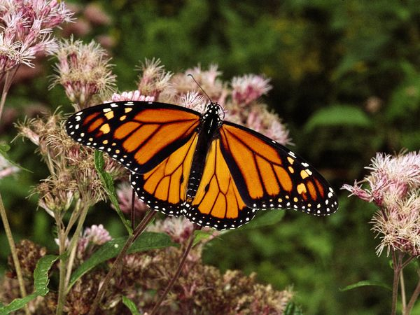

Standard 3
EXPENDITURES:
Tree Planting and Initial Care
(Tree purchases, labor and equipment for planting, planting materials, staking, watering, mulching, competition control) | $ 100,000.00
Campus Tree Management  (Pruning, public education, professional training, association memberships, campus tree inventory, pest management, fertilization, tree removals, Invasive removal) | $ $350,000.00
Volunteering hours:  # of students: 64h x $18/h | $ 1,152.00*
TOTAL: | $ 451,152.00
*2021 has been partially challenging in getting projects volunteering due to the pandemic.

- Number of trees planted:
CG campus= 8
- Number of trees maintained:
CG campus= 8,876 (Removal of invasive, pruning, clearance requirements)
- Tree removed:
CG campus = 14
- Reason for removal: Hazardous conditions
- Volunteering hours:
volunteering hours on campus, arboretum, garden = 64 volunteering hours
- Full Time Student population: 17,809
Standard 4
Arbor Day Observance on April 23. 2021
-Virtual Panel on Arbor Day: “THE ATALA RESURGENCE AT LAKESIDE VILLAGE”
https://greenu.miami.edu/topics/nature/tree-campus-usa/index.html
Standard 5
Service Learning Projects Educational and recreational projects in 2021:
- Aug. 28, 2020 at UM - Butterfly Garden in the Arboretum: In the summer, volunteers and the faculty Dr. Terry Hood and the director Mauro Galetti help to plant a new butterfly garden.

- Fall 2020: Ecosystem Science & Policy classes and activities in the Gifford Arboretum & Sustainability Garden (PDF)
- Fall 2020: The University of Miami’s Gifford Arboretum, a resource for research and outreach within our community (PDF)
- Fall 2020 Research: The Defaunation Lab. in the Department of Biology is investigating the effects of fruit-eating animal loss on plant distribution (PDF).
2020 Educational and recreational projects:
https://arboretum.as.miami.edu/calendar/index.html
All the events scheduled for the year had to be cancelled because of the pandemic.
Dr. Mauro Galetti, the new arboretum director and associate professor, is a conservation ecologist with more than a decade of experience researching the rainforests. He started his new role at UM in January 2020 and had very little time to adapt before the pandemic strike. A lot of events had been planned in a very short amount of time, but unfortunately very few could be programmed. We are certain that under Dr. Galetti’s leadership, in partnership with our community organizations, our faculty and student government ECO agency, we will be ready to expand sustainable tree care and tree planting as soon as Covid19 is behind us.
https://greenu.miami.edu/topics/nature/volunteer-with-the-arboretum/index.html

